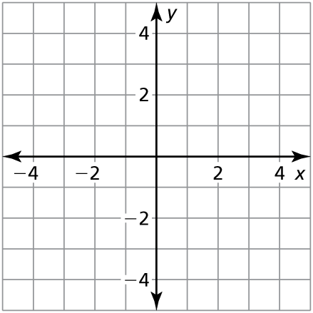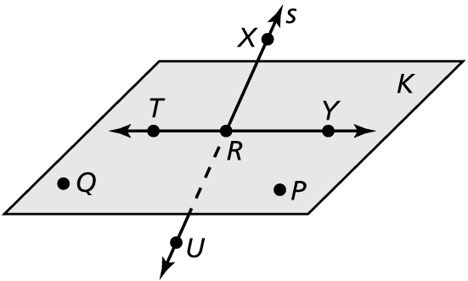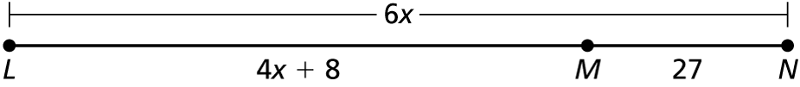TA: C:\2014 Projects\EPSs_PNGs_Word\geo\Arts\PNGs\HSGeo_ab_0100_004.pngName Date

Test A

Chapter

1

Answers

1.

2.

3.

4.

5.

6.

7.

8. See left.

9.

10.

1. Find the length of  Explain how you found your answer.

2. A map shows a section of Highway 18 that forms a straight line. A family plans to drive 440 miles on Highway 18 from Springfield to Columbia.   
They drive for 66 miles, and then decide they will stop halfway through   
their trip to rest for the night. How much farther do they need to drive   
before they stop for the night?

3. Point *M* is between points *L* and *N* on   and  Use the information to solve for *x*, and then find *LN*.

**Use the diagram.**

4. Give another name for line *S*.

5. Name three points that are coplanar.

6. Name three points that are collinear.

7. Give another name for plane *K*.

8. Plot the points in a coordinate plane. Then determine whether  and  are congruent: **

9. The endpoints of are ** Find the coordinates of the midpoint *M*.

10. The midpoint of  is ** One endpoint is ** Find the coordinates of endpoint *S*.

Name Date

Test A **(continued)**

Chapter

1

Find the perimeter and area of the figure shown.

Answers

11.

12.

13.

14.

15.

16.

17.

18.

19.

20.

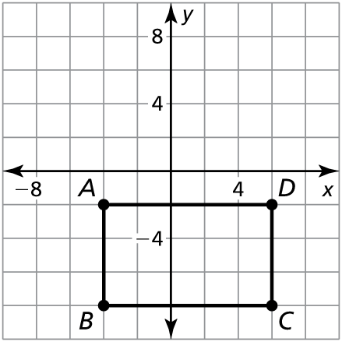 11.

Identify the segment bisector of  Then find *XY*.

12. 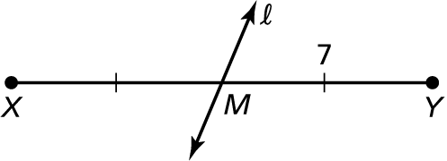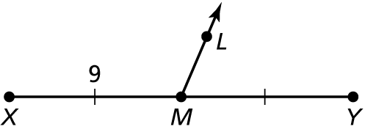 13.

 bisects Use the diagram and the given angle measure to find   
the indicated angle measures.

**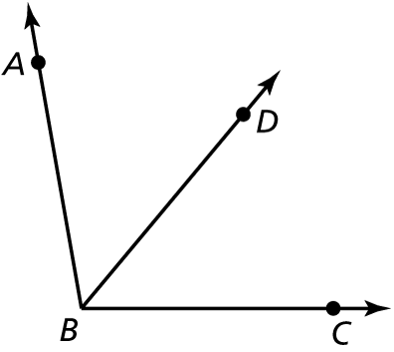**

14.  Find  and 

**15.**  Find  and 

16.  Find and 

Find the angle measure.

17. is a supplement of and  Find 

18. is a complement of and  Find 

**19.** is a supplement of and  Find 

**20.** is a complement of and  Find 