Writing a Prediction Equation by Hand
1. Create a scatterplot.
2. Construct the line of best fit and choose 2 points on the line.
3. Write the equation of the line of best fit.
a. Find the slope.
b. Plug the slope and one point into the point-slope formula.
c. Solve for y.

Ex 1)
The table shows the humerus lengths (in centimeters) and height (in centimeters) of several females.
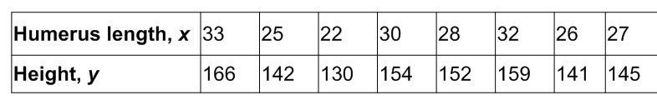
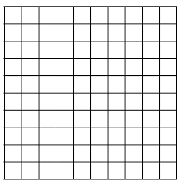

a. Do the data show a linear relationship? If so, write an equation of a line of fit and use it to estimate the height of a female whose humerus is 40 centimeters long.

Writing a Prediction Equation using the Graphing Calculator.
*Scatterplot feature must be turned on!
1. Enter your data into L1 and L2.
2. Identify the domain and range of the data and set your window accordingly.
3. Graph.
4. Use the Linear Regression feature to calculate the line of best fit.
5. Interpret the correlation coefficient to determine the accuracy of the line of best fit.

Ex2) Use the data from example 1 to create a line of best fit using the graphing calculator.

a. Determine the domain and range of the data given.

b. Find and interpret the correlation coefficient.

c. Estimate the height of a female whose humerus is 40 cm long. Compare this height to your estimate in example 1.

